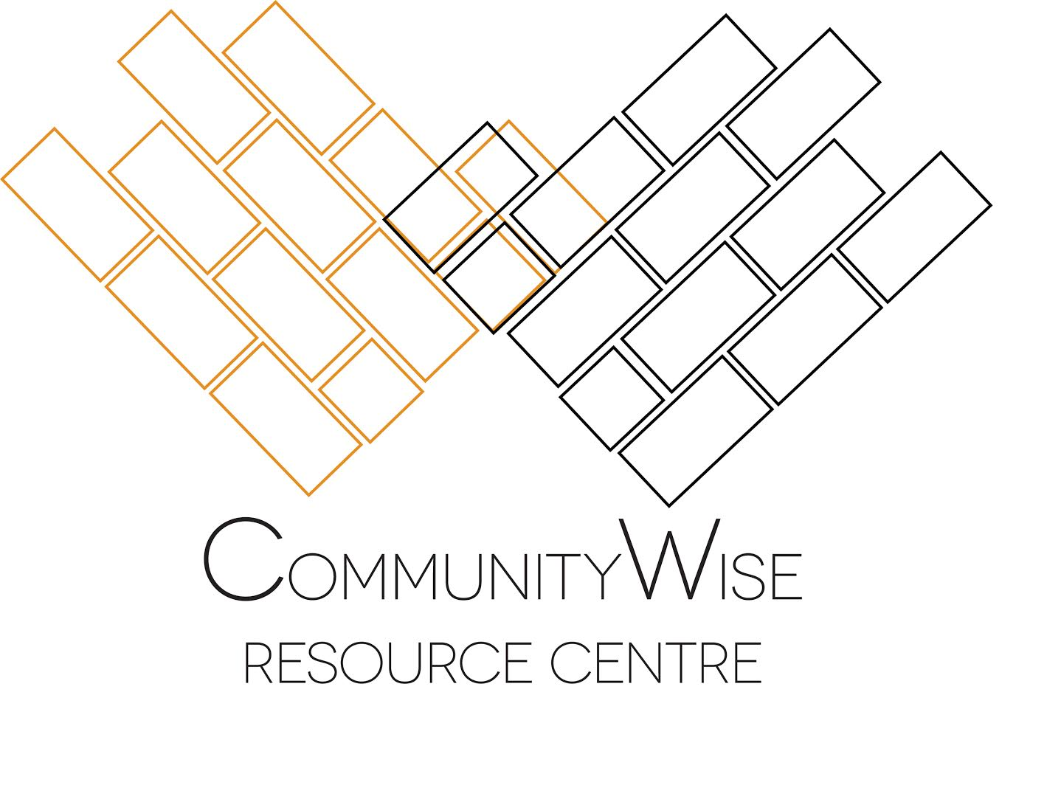
CommunityWise Resource Centre
ANNUAL GENERAL MEETING 2016

M.C.: Reg Tiangha
Minutes: Erin McFarlane
Timekeeper: Dheny Rivas

Attended: Son Edworthy (CommunityWise staff collective); Philip McCutcheon (CommunityWise staff collective); Jian Hong (CommunityWies staff collective); Erin McFarlane (CommunityWise staff collective); Kyla Myles (CommunityWise practicum); Sobia Noreen (CommunityWise practicum); Reg Tiangha (Gear Station, CommunityWise Board); Susan Bareshinebone (AFCC, CommunityWise Board); Tove Engebretsen (community member, CommunityWise Board)
Corinne Craig (SEEDS Connections, CommunityWise Board); Curtis Boudreau (SMART Recovery, CommunityWise Board); Rick McFerrin (Two Wheel View, CommunityWise Board); Courtney Robertson (community member, CommunityWise Board); Carmin Moore (ACT Alberta); Helen Mok (Foothills Library Association); Joe Pimlott (AFCC); Erin Jenkins (Refuge Recovery); Aminah Malik (Refuge Recovery); Mike Simoens (CCGC); Gerald Wheatley (Arusha); Mike Byerley (Next Up); Kevin Allen (individual member); Greg Lang (JAWS); Kim Brown (JAWS); Joseph Portincasa (JAWS); Moe (Oromian Community Association); Tyson Bankert (community); Josh Carter (community); Dheny Rivas (community); Jamie Zarn (community)

AGENDA

Thursday, May 19, 2016
Doors at 6:00
6:30 to 8:30 pm

1. Introductions and Opening Comments 6:30
- Reg called meeting to order at 6:45pm
- Noted amendment to change agenda item #8
  - Bylaw changes will be moved to SGM at August Board Meeting

2. Approve the agenda for AGM May 19, 2016
- Proposal (Reg Tiangha): Accept agenda with amendment to item #8 (bylaw changes moved to SGM at August Board Meeting)
Consent: 20
Opposed: 0
Abstained: 0
Proposal passed

3. Approve the minutes of AGM May 21st, 2015
- Proposal (Reg Tiangha): Accept 2015 AGM minutes as presented
Consent: 19
Opposed: 0
Abstained: 1
Proposal passed

4. Business Arising from Minutes of May 21st, 2015
- No business deferred from May 2t, 2015
5. Annual Report
- Staff Collective gave annual report via slideshow
(Practicums; Collaborative Framework; Programming; Financial; Facilities)

6. Presentation of 2015 Audited Financial Statements 6:50

- Jian provided overview of statements (at 7:10pm)
Proposal: (Reg) Accept the 2015 Audited Financial Statements as presented
Consent: 19
Opposed:0
Abstained: 1
Proposal passed

- Question (Colin Mahau, BGCC): What is self-supported programs line?
  - Answer (Jian and Phil) Equinox Vigil project; no longer supported by CommunityWise in 2016

- Proposal: Accept Lockhart LLP as auditor for 2016
  - Question (Kevin Allen, Outlink): Are we required to have audited financial statements rather than review?
    - Answer (Son): Audited statements is a decision made by CommunityWise

  - Question (Corrine, SEEDS): Is CommunityWise happy with these auditors?
    - Answer (Jian): Audit cost more than quoted
    - Unclear whether we should continue on with them

- Proposal (Corrine, SEEDS): Approve this auditor for now, but also put in a proposal to have someone investigate other auditors

- Proposal (Reg Tiangha, reframed): Appoint Lockhart LLP as auditor until close of 2017 CW AGM dependent on some level of investigation by Finance Committee into other auditors
In favour: 18
Opposed: 0
Abstained: 1
Proposal passed

7. Announce Rent Increase 2017
- Phil and Son explained that rent increase is due to CW taking over payment of utilities that were previously covered by the City of Calgary
- Equity Framework used, taking into account factors that impact groups differently, with all attempts to be equitable (factors used: charitable status; number of staff hours; organizational budget size)
- Rent Equity Townhall scheduled for Thursday, July 7 at 6pm

- Question (Greg Lang, JAWS): Clarification that this is only for offices and not common spaces?
  - Answer (Phil): Correct

- Question: Is there a plan to implement incremental increases over time, rather than large amounts at once?
  - Answer (Phil): Yes, this is part of the Finance Committee’s plans

- Question (Mike Simoens, CCGC): Why did the City stop paying for this?
  - Answer (Phil and Son): City paying for utilities dates back to when CommunityWise and Beltine buildings were collectively the YWCA; system now in place for CommunityWise to be invoiced for its share of utilities

8. Proposal to approve Bylaws 2016
- Tabled to August Board meeting SGM
9. Acclamation of the new board 7:25
- Board members stepping down:
  - Tove Engebretsen – after 2 years
  - Ginger Carlson – after 2 years
  - Rick McFerrin – after 3 years (full term)

- Returning Board members:
  - Reg Tiangha (Gear Station, Associate Member)
    - 1 year (first term)
  - Susan Bareshinbone (Aboriginal Friendship Centre, Tenant Member)
    - 1 year (first term)
- Curtis Boudreau (SMART Recovery, Associate Member)
  - 4 years (second term)
- Corinne Craig (SEEDS Connections, Tenant Member)
  - 1 year (first term)
- Courtney Robertson (Community Member)
  - 4 years (second term)
- Lori DeLuca (Community Member)
  - 2 years (first term)
- Seth Leon (ACCA, Tenant Member)
  - 3 years (first term)
- Sally Truss (This is My City, Associate Member)
  - 2 years (first term)
- Ernesto Gudino (VCAC, Associate Member
  - 2 years (first term)

- Standing election:
- Carmin Moore (ACT Alberta, Tenant Member)
- Helen Mok (Foothills Library Association, Associate Member)
- Mitiku Wakwaya (Oromo Society Network, Associate Member, absent, Reg read bio)

- Question (Reg Tiangha): Does anyone have any issues if we vote all three standing election today?
  - No issues raised

- Proposal: Carmin Moore, Helen Mok, and Mitiku Wakwaya (absent) appointed to CommunityWise Resource Centre Board of Directors
Consent: 19
Against: 0
Abstained: 0
Proposal passed

10. Awards ceremony 7:40
- Son and Jian presented awards:
  - Spirit of the Old Y: Oromian Community Association of Alberta (in building since 1983)
    - Moe accepted the award and spoke about the organization’s work
  - Spirit of CommunityWise (two winners):
- Calgary Women’s Heath Collective (in building since 1980s)
    - Kelsi read note sent from the Collective
- Justice for Palestinians Calgary
    - Cathy and Mariam accepted award
  - Active New Tenant Member: SEEDS Connections
    - Corinne accepted the award
  - Active New Associate Member: Refuge Recovery
    - Erin accepted the award
  - CommunityWise Collaborator Award (two winners):
- Beltline Youth Centre (BGCC)
- Sheliza accepted the award
- Aboriginal Friendship Centre
- Susan accepted the award

11. Announcements 7:50
- Proposal (Reg Tiangha): to adjourn 2016 CommunityWise AGM at 8:17pm
Consent: 19
Against: 0
Abstained: 0
Proposal passed

12. Outside to take a photo 7:55
13. Bingo/ Snacks/ Mingle 8:00 onward

